**Building Architecture of AWS Public/Private Subnet**   
  
This example demonstrates how to create a VPC that you can use for servers in a production environment. To improve resiliency, you deploy the servers in two Availability Zones, by using an Auto Scaling group and an Application Load Balancer. For additional security, you deploy the servers in private subnets. The servers receive requests through the load balancer. The servers can connect to the internet by using a NAT gateway. To improve resiliency, you deploy the NAT gateway in both Availability Zones.

**Contents**

1. Create the VPC

2. Deploy your application

3. Test your configuration

4. Clean up  
  
**Overview**

The following diagram provides an overview of the resources included in this example. The VPC has public subnets and private subnets in two Availability Zones. Each public subnet contains a NAT gateway and a load balancer node. The servers run in the private subnets, are launched and terminated by using an Auto Scaling group, and receive traffic from the load balancer. The servers can connect to the internet by using the NAT gateway. The servers can connect to Amazon S3 by using a gateway VPC endpoint.

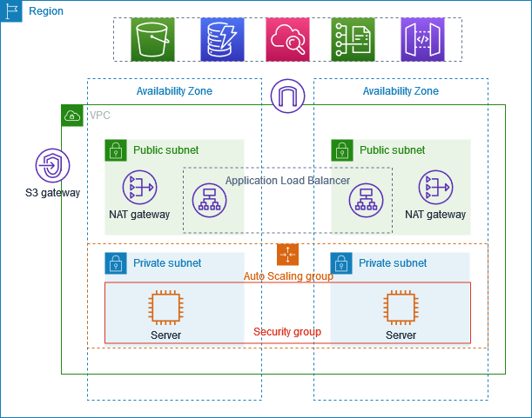

**1. Create the VPC**

Use the following procedure to create a VPC with a public subnet and a private subnet in two Availability Zones, and a NAT gateway in each Availability Zone.

**2. Autoscaling Group-**

-Launch Template Creation 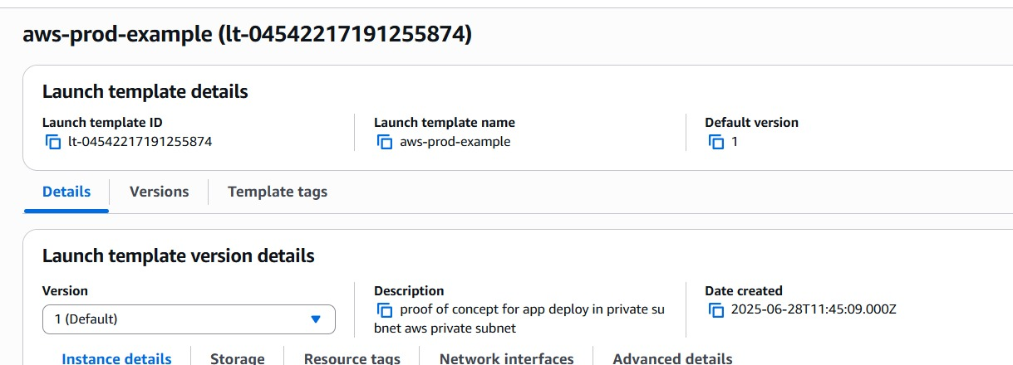

**3. Bastian Host (Jump server creation)**  
 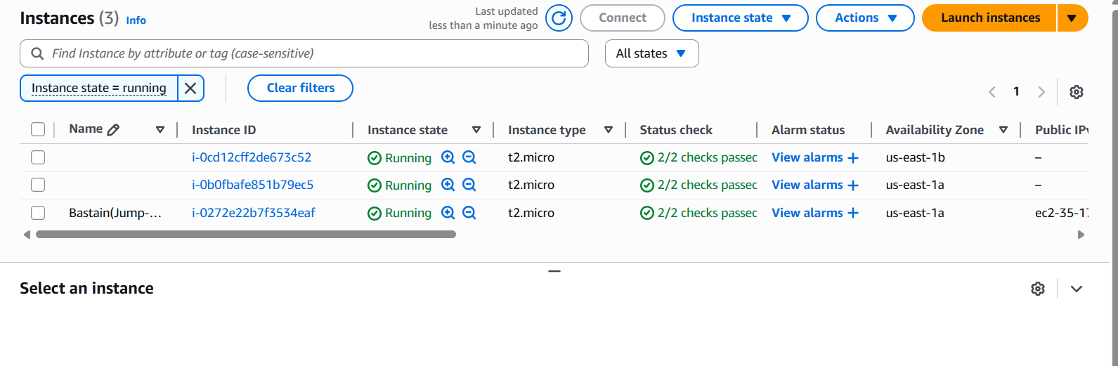

-Accessing Private Subnet-Server through Jump Sever  
 scp -i "C:\Users\Administrator\Downloads\Project-Aws.pem" C:\Users\Administrator\Downloads\new-key.pem \Users\Administrator\downloads ubuntu@35.XXX.XX.XX:/home/ubuntu/  
  
  
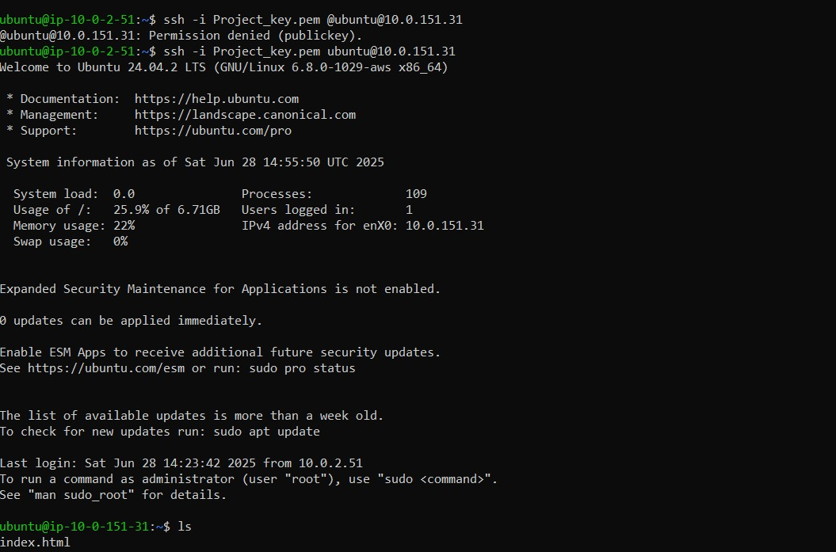

**4. Creation of Load Balancer**

-Target Group Creation  
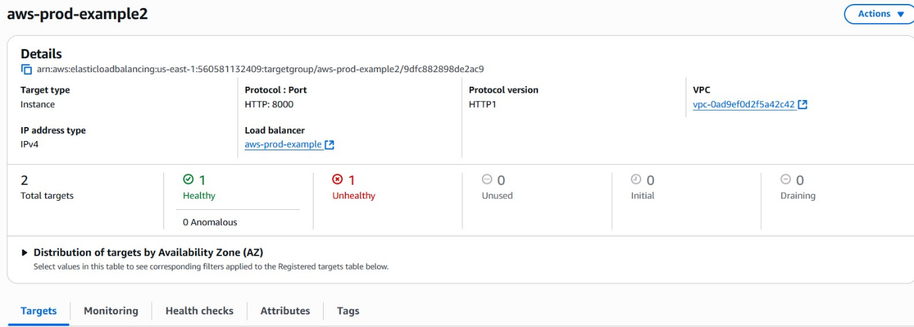

**5. Deployment of Web Application**  
  
